Types of approaches/ perspective (related to personality)

* Biological — **genes** = personality
* Behaviorism — **conditioned** behavior = personality; the outcome (NOT cognition) determines the behavior
* Psychoanalytic — **unconscious** mental life and the results of the id/ ego/ superego struggle = personality
* Humanistic — **conscious** feelings we have for ourselves + **free will** actions to improve self = personality
  + Maslow: not everyone can reach self-actualization (being self-aware, having higher purpose)
  + Rogers: self-actualization is a constant process that is nurtured in a growth-promoting environment; genuinity to oneself + acceptance from others (unconditional positive regard) = self-concept
* Social-cognitive — interplay between personal choice and environmentinfluences behavior = personality; based on the principle of **reciprocal determinism**, where **cognitive factors** (self efficacy, locus of control), behavior, and **environmental** (**observational learning**) all influence each other.

Types of approaches/ perspective (related to society)

* Biological — **nature**, evolution
* Biomedical — considers the physical and **medical** causes of apsychological disorder
* Biopsychosocial —considers the effect of **biological**, **psychological** and **social** components on a disease or disorder
* Life course — concerned with how **early life** events affect **later life outcomes**
* Social epidemiology — focuses on the **social determinants** of **health** and diseases
* Medicalization — the process in which a **social problem** comes to be defined as a **disease** or disorder
* Macrosociology perspective — large scale perspective, looking at social structures, institutions, societies, populations, civilizations for patterns i.e. **the effects of big picture on life of small groups and individuals**
  + Functionalism
  + Conflict theory
* Microsociology — looking at small scale everyday, face-to-face interactions between individuals or maybe small groups (family, schools), then interpret **how those individual interactions would affect the larger patterns of society**
  + Symbolic Interactionism

Actor-Observer Bias

* When looking at the behavior of others, we tend to commit **Fundamental Attribution Error** (more common in individualistic cultures) → more likely to attribute their behavior to internal factors
* When looking at your own behavior (there is no term to describe this), we are more likely to attribute our behavior to external factors

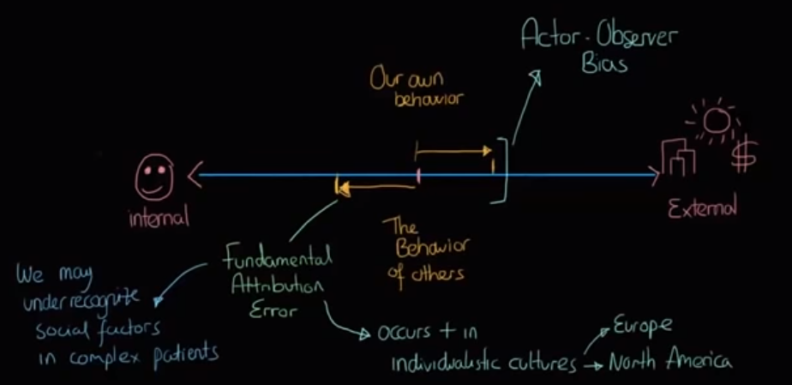

How cultures view successes/ failures

* Individualistic cultures tend to attribute success to internal factors, and failures to external factors (They are more likely to commit self-serving bias too)
* Collectivist cultures tend to attribute success to external factors, and failure to internal factors

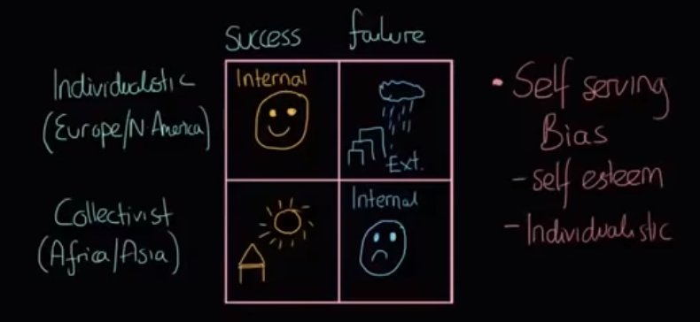

Covariation model

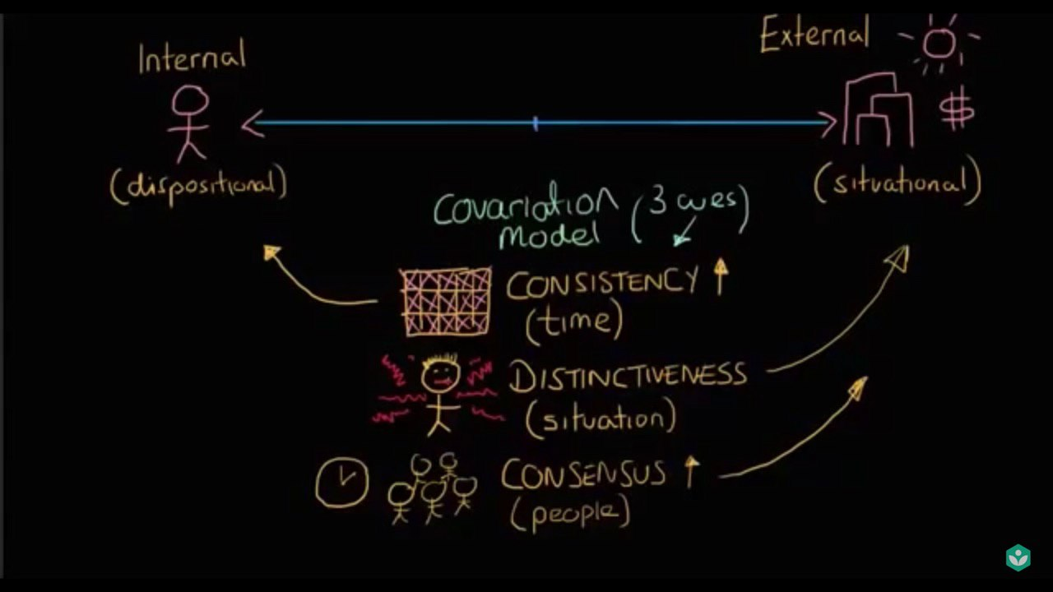

Self-verification

* Refers to the tendency to seek out (and agree with) information that is consistent with one’s self-concept

Thomas Theorem

* “If men define situations as real, they are real in their consequences.”
* In other words, the interpretation of a situation causes the action
* Examples
  + Guy in prison with a violent history thinks other people in the prison are talking about him even though they aren’t, but, since he thinks they are he goes over and hits them. His perception of the situation led to the action
  + Boy is scared of ghosts so he can't sleep. His behavior is determined by his belief, not reality.

George Hebert Mead - The I and the Me

* Believes that young children are not influenced by others in any way - they see themselves as the focus of their own world
  + Similar to Piaget’s concept of ego-centricism

1. Preparatory stage
   1. Imitation
2. Play stage
   1. Pretend play
   2. Role-taking (not just imitation, but also creation)
3. Game stage
   1. Generalized other (or society as a whole)
   2. Multiple roles (e.g. teachers do not just teach)
   3. Only care about the perception of the Significant other (e.g. family, friends)

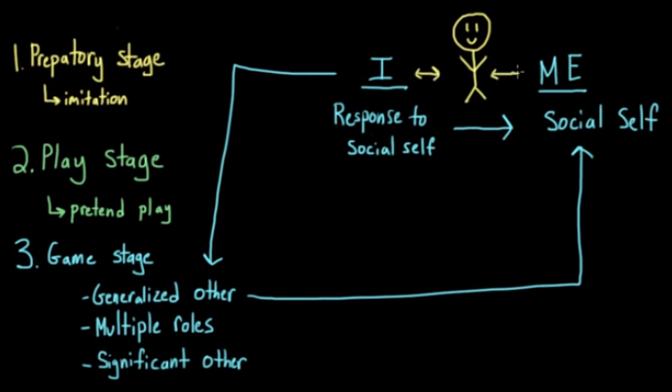

* Me: The society’s view
  + The part of the self that is formed in interaction with others and with the general social environment, i.e. the socialized and conformed aspect of self
  + How we believe the generalized other sees us. It is what we learn through interactions with others
* I: The individual identity stepping in, or our personal responses, to what society thinks
  + The spontaneous and autonomous part of the self i.e. the spontaneous, less socialized component of the Self
  + Thinks about what those things mean

Example

* The “Me” might understand that people in the US go from high school directly to college but the “I” might wonder if that is best (e.g. maybe it is better to work first)

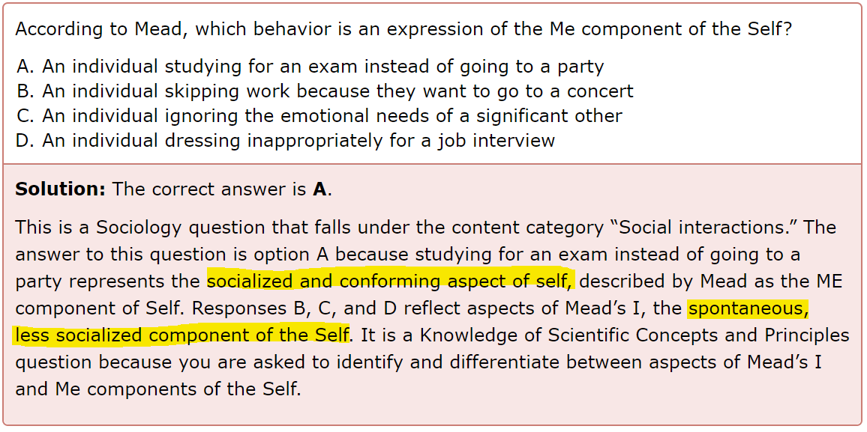

Looking Glass Self

* Three steps
  + How do I appear to others?
  + What must others think of me?
  + Revise how we think about ourselves
* We are not actually being influenced by the opinions of others, but instead we are influenced by what we imagine others’ opinions to be

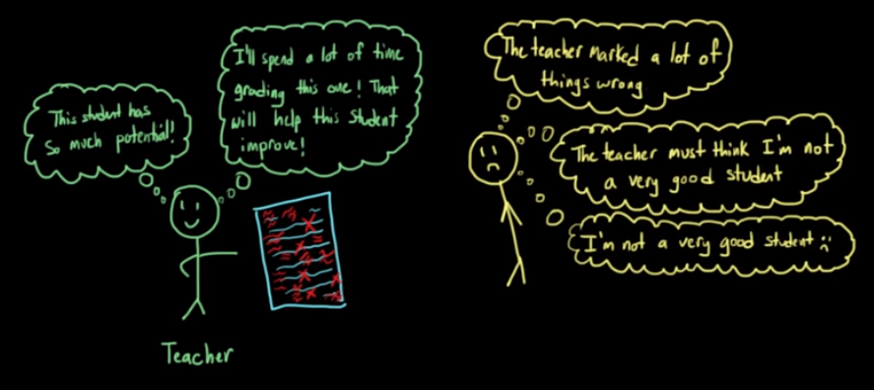

Frustration-aggression Hypothesis vs Hypothesis of Relative Deprivation

* Frustration-aggression hypothesis assumes that people will be more aggressive when they are frustrated, and that being hindered from a desired goal (e.g. playing with an attractive toy) is frustrating
  + Since they cannot channel their aggression towards their employer (because they will risk losing their job), they are likely to channel it to the minorities
  + This is called scapegoating
* The hypothesis of relative deprivation suggests that people become very frustrated show an upsurge in prejudice and discrimination when people feel deprived of something they feel entitled to (due to differences in expectations and what they actually get)
  + Can lead to collective unreset

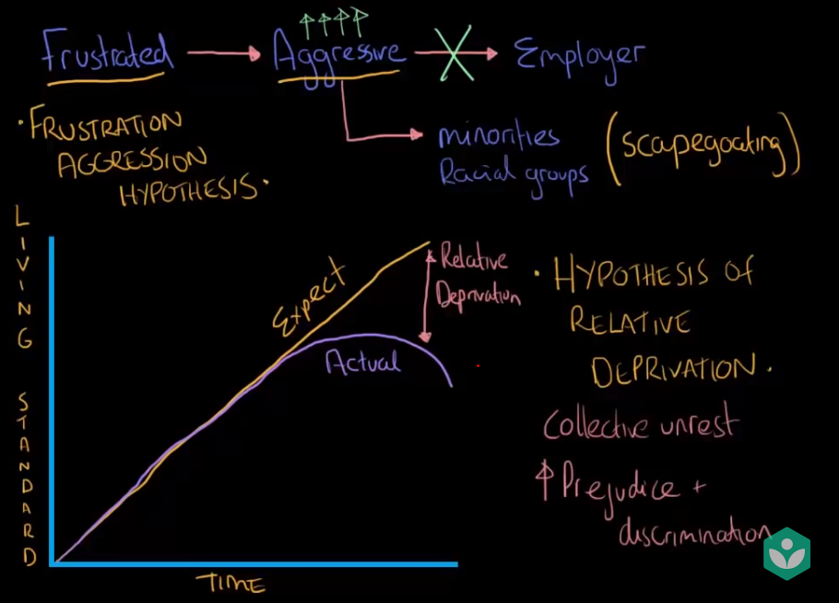

Theories of Emotion

* Two-factor theory, i.e. Schachter-Singer Theory, must include **interpretation** of arousal/ context (some form of cognitive appraisal)

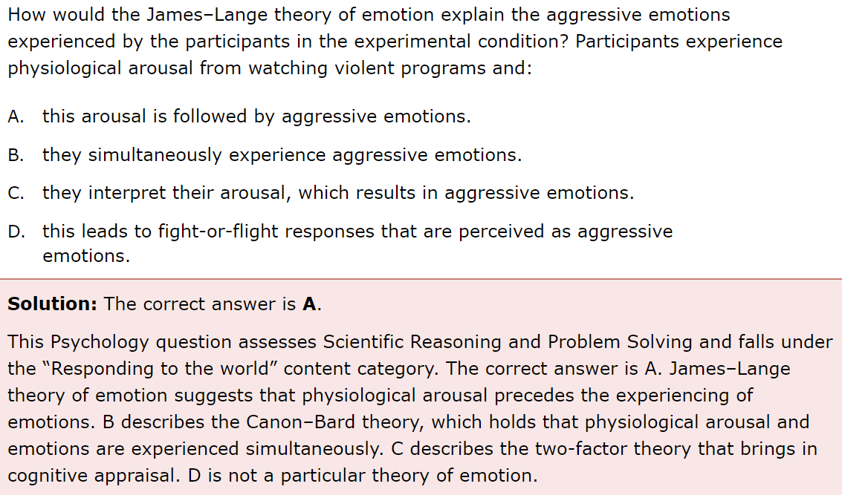

Globalization Theory

1. World Systems Theory
   1. Focuses on the world as a unit, rather than looking at individual countries
   2. A fluid model, but it is criticized for being too focused on the economy and the core countries, and forgetting about the culture and even the class struggles of individual countries
   3. Divides the world into three regions:
      1. Core countries (e.g. Western Europe, United States)
         1. Have strong central government with enough tax to support it
         2. Economically diversified, industrialized and relatively independent of outside control
         3. Have strong middle and working classes, and focus on higher scope production of material goods rather than raw materials
      2. Periphery countries (e.g. Latin America, Africa)
         1. Tend to have relatively weak government
         2. Depends on only one type of economic activity, e.g. extracting raw materials
         3. High percentage of poor and uneducated people, as well as a small upper class which controls most of the economy → creates huge inequality
         4. Greatly influenced by core countries and transnational corporations which can harm the future economic potential of the periphery countries
      3. Semi-periphery countries (e.g. India, Brazil)
         1. Make up the middle ground between core and periphery
         2. Often not dominant in international trade but have a relatively diversified and developed economy
         3. Can come from periphery countries moving up toward industrialized core countries, or from core countries declining toward periphery status
2. Modernization Theory
   1. Proposes that all countries follow a similar path of development from a traditional to a modern society
   2. Assumes that with some help, traditional countries can develop into modern countries in the same way that today’s modern countries developed in the first place
   3. Looks at the internal social dynamics as the country adapts to new technologies, and the political and social changes that occur
3. Dependency Theory
   1. Reaction to modernization theory
   2. Uses the idea of Core and Periphery Countries from the World Systems Theory to look at the inequalities between countries
   3. Proposes that periphery countries or third world countries are poor, and export resources to the wealthy core or first world countries
      1. Not because they are in an early stage of development, but because they have been integrated into the world system as an undeveloped country
      2. They have their own structures and features not seen in developed countries and will not accelerate to become a developed nation
      3. They are in an unfavorable economic position → they do not even have the opportunity to improve and develop
      4. They will remain poor and dependent on wealthier nations
4. Other Perspectives
   1. Hyperglobalist
      1. Individual countries become one global society
   2. Skeptical
      1. International processes become regionalized rather than globalized
   3. Transformationalist
      1. Unsure of the specific cause or outcome of globalization because there are so many factors

Assimilation vs Accommodation

* Assimilation = adding new ideas to the framework
  + Fitting the same schema
* Accommodation = restructuring the framework to allow for the incorporation of new ideas
  + Changing existing schema or creating new schema

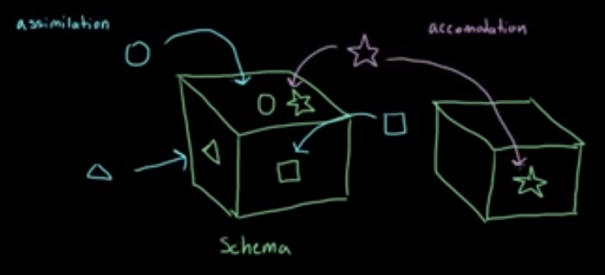

Types of memory storage

* There are three stages of memory
  + **Sensory memory** is the first recall of sensory information; it is quick and short-term. For example, if you touch a pan on the stove, you will remember it was hot.
    - **Echoic memory**- the memory of a sound (very brief, lasting only as long as about 4 seconds). For example, the specific sound of a bird chirping.
    - **Iconic memory**- the memory of an image (even more brief than echoic memory, lasting not even a full second). For example, the color of a stranger's eyes.
  + **Short-term memory** is a memory that is of short duration, approximately 20 seconds. An example of this could be remembering someone's address just long enough to type it into your GPS. A subset of short-term memory is the working memory, which refers to the immediate processing of events and linguistics. This is the type of memory that we use most often in school when learning a new concept.
  + **Long-term memory** is a memory that can last infinitely, for example, remembering the date you were born, the face of your mother, etc.
* Other types of memory
  + **Declarative memory** (also known as explicit memory) refers to the memorization of information to the point where the person is able to "declare" it. For example, when you remember a song and are able to sing along to the lyrics.
    - **Episodic memory** refers to memories surrounding a specific (often important or meaningful) event. For example, remembering the specific details of and surrounding a serious car crash, and your own residential address
    - **Semantic memory** refers to memories of facts, such as the name of the president.
  + **Nondeclarative memory** (also known as implicit memory)
    - **Procedural memory** (also known as implicit memory) is the memorization of how to complete a task. For example, one would exercise procedural memory when driving a car.
  + **Autobiographical memory** refers to the collection of memories that we collect about ourselves over a lifetime. Such memories include life events, relationships with people, emotions, etc.
  + **Retrospective memory** refers to memories of things that have happened in the past. This is the type of memory we are using when learning about historical events, etc. Retrospective memory includes episodic, semantic, declarative, and autobiographical memories.
  + **Prospective memory** refers to memories that must be had in the future. For example, one might say to themselves "I must remember to get milk when I go to the grocery store." This is an example of prospective memory.
  + **Flashbulb memory** refers to the the subjectively vivid, compelling memories of details associated with reception of news about emotionally arousing events
  + **Eidetic memory** refers to the ability to recall, with high precision, an image after only a brief exposure; it is hypothesized that eidetic memory represents an extreme example of iconic memory that endures for a few minutes
  + **Reproductive memory** refers to the recall that is hypothesized to work by storing the original stimulus input and reproducing it during recall; it is like “total recall of the episode”
  + **Reconstructive memory** is a theory of memory recall, in which the act of remembering is influenced by various other cognitive processes including perception, imagination, semantic memory and beliefs, amongst others; in the absence of all information, we fill in the gaps to make more sense of what happened; intrusions can happen

Emotional arousal on memory

* Emotional arousal seems to focus a person’s attention on the central features of an event.
* The hypothesis (Easterbrook, 1959) that a person will notice information that elicits arousal, but fail to process other information, has been supported by studies in which memory for an (*emotional*) event’s “central” aspects (directly tied to the emotion elicitor) is compared to memory for “peripheral” aspects (removed from the source of the emotional arousal).
* Thus, memory for the fundamental gist of the emotional event is retained, whereas memory for details (if they are encoded at all) either fades or undergoes changes.

Aging

* Diminishes
  + Capacity for acquiring new declarative (episodic) information
  + Capacity for controlling his or her memory processes
  + Ability to cope with Alzheimer’s Disease
* Does not diminish
  + Ability to retrieve general information (i.e. semantic memory, crystallized intelligence)

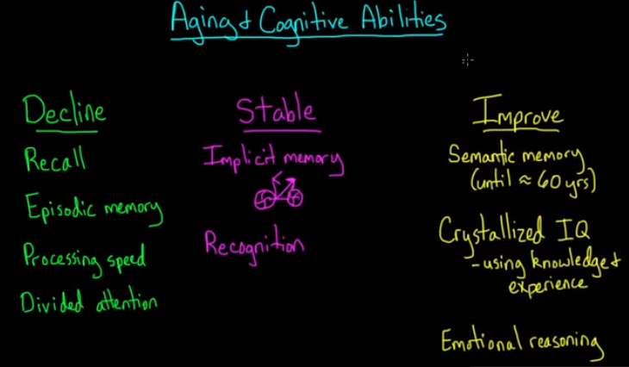

Source Monitoring Error vs Source Amnesia

1. Source Monitoring Error (remembers the source wrongly)
   * E.g. You think you first heard about a tragic event while watching the news on TV, while you actually first heard about from someone mentioning it at work
2. Source Amnesia (cannot remember the source)
   * E.g. You cannot recall what source first informed you about the tragic event

Types of Testing

* Partial report technique
  + Relates to Sperling's experiments on **sensory (iconic) memory**; he would flash a grid of numbers at participants and then immediately ask them to recite a particular row or column; it is in contrast with a **full report technique**, where he would just ask them to report anything they could remember
* Psychophysical discrimination testing
  + Participants are asked to differentiate between two stimuli (either by saying it exists or describing it somehow quantitatively); related to the **just noticeable difference**
* Word association testing
  + A test in which the tester gives the patient words and the patient responds with the first thing that comes to mind; used by **psychoanalysts like Jung** to infer **subconscious thoughts or personality traits**
* Operational span testing
  + Testing of the capacity of **working memory**; researchers alternate between presenting a word to be remembered, then asking participants to verify a simple math equation (to interrupt rehearsal), after which the participants are tested to see how many words they remember

Cognitive Dissonance

* Discomfort experienced when holding two or more cognitive cognitions, which can be ideas, beliefs, values or emotional reactions
* This feeling can lead to alterations in our beliefs/ attitudes/ behaviors to reduce the discomfort we feel about inconsistencies
* **Research on cognitive dissonance has found that these people tend to change their attitudes to match their behaviors, rather than change their behaviors**
* E.g. A person likes to smoke, but he understands that smoking leads to cancer. Possible alterations include:
  + Modify: “I really don’t smoke that much”
  + Trivialize: “The evidence is weak that smoking causes cancer”
  + Add: “I exercise so much it doesn’t matter that I smoke”
  + Deny: “Smoking and cancer are not even related”

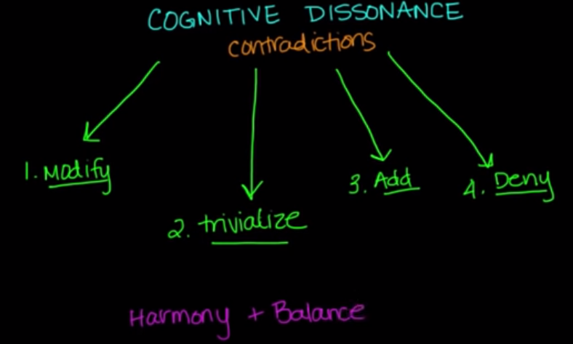

Absolute Mobility vs Exchange Mobility

* Absolute Mobility
  + Means that living standards are increasing in absolute terms: you are better off than your parents and your children will be better off than you
  + Compares your income to your parent’s income. If your parents make $5,000 dollars a year and you make $10,000 dollars a year, you have experienced absolute mobility
  + It is not a demographic measure
* Exchange Mobility
* A sociological concept that suggests society is made up of classes and that these classes maintain a relatively static number of people.
* Think of it as society consisting of various classes and those classes are in "equilibrium"; if an x amount of people move up from lower class to higher class, then an x amount of people will also fall from the higher class to the lower class.

Social Capital vs Cultural Capital

* Social capital
  + Refers to your social network (this is NOT the same as having material resources)
  + E.g. rich/successful people tend to have rich/successful friends who can help them with career opportunities.
* Cultural capital
  + Refers to how "cultured" you are - dressing well, speaking eloquently, interest in arts/music, education level, etc
  + E.g. a lawyer who wears nice suits and has a taste for fine wine and art has lots of cultural capital

Stereotype vs Prejudice vs Discrimination vs Stigma

* Stereotype
  + Refers to **cognitions** regarding social groups, NOT behaviors toward social groups
  + E.g. Malays are lazy
* Prejudice
  + Preconceived opinions (making assumptions) or **attitudes** that are usually negative and not based on any facts or experience
  + E.g. I don’t like Malays
* Discrimination
  + Involves **behavior/ action** – the irrational, often negative treatment of a person or group as a result of prejudice
  + E.g. I will not hire Malays
  + Can be divided into:
    - Individual Discrimination
      * When this **action is undertaken by an individual** independent of larger organizations
      * E.g. an employer who holds the prejudice that women are unintelligent may discriminate by refusing to hire them
    - Institutional discrimination
      * **Discrimination is written into the laws, policies, and unwritten procedures of society**
      * E.g. a mortgage policy that, due to its requirements, makes it particularly difficult for ethnic minorities to obtain loans.
* Stigma
  + Strong social disapproval and even outright rejection of a stigmatized group
  + Typically, stigma is reserved for people or groups who break important social norms.
  + Unlike stereotype and prejudice, stigma is always a highly negative perception
  + Can be social stigma or self stigma

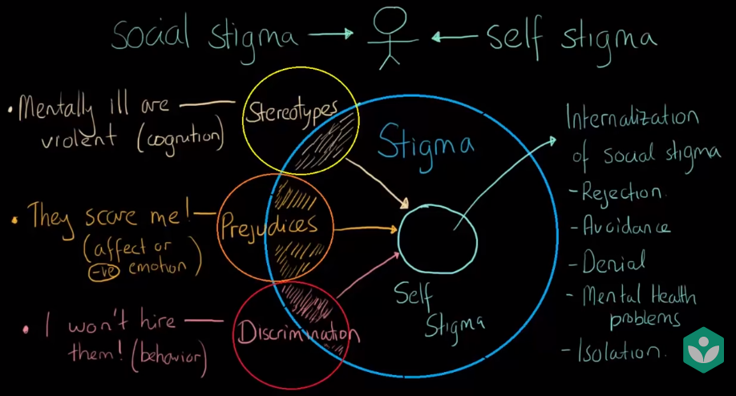

Self-efficacy vs self-concept vs self-esteem vs social identity

* Self-efficacy - do you believe in yourself that you have the ability or are good enough for the task at hand? (ie. We need good self-efficacy for this MCAT)
* Self-concept - the awareness you have of yourself based on what you believe and what people tell you. It can include your self-esteem and self-image if you take it by Carl Rogers' definition.
* Self-esteem - this is all about your feelings of worth and self-respect. This can be severely damaged by bullying or other forms of attack because you potentially feel less valuable.
* Social Identity - this is about where you feel you belong in a group or society. You can compare this to social cliques; the people of those groups tend to share a common identity of some form.

Self-concept vs Social Identity (more in-depth from Khan Academy)

* Self-concept (being self-aware) has two aspects:
  + Existential (separate, distinct, constant)
  + Categorical (age, gender, etc) e.g. “I am a boy. I am five years old”
* Carl Rogers believed that self-concept has three different components:
  + Self-image (the view we have of ourselves)
  + Self-esteem (self-worth; how much value we put in ourselves)
  + Ideal self (who we wish to be)
* Social Identity Theory can develop self-concept further in two parts:
  + Personal (things that are unique to each person e.g. personality traits)
  + Social (includes groups that you belong in a community) → three steps to understand this:
    - Categorization (e.g. by race)
    - Identification (e.g. if you identify yourself as a student, you will behave and act like a student)
    - Comparison (maintain self-esteem)

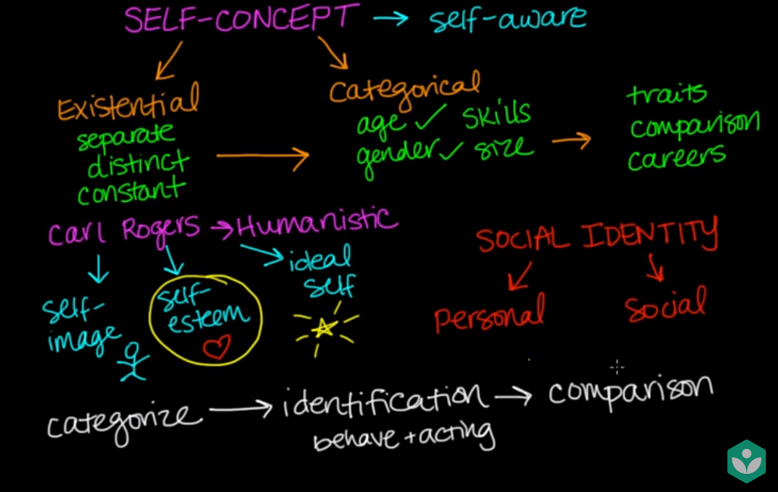

Operant Conditioning

* Aversive conditioning = positive punishment

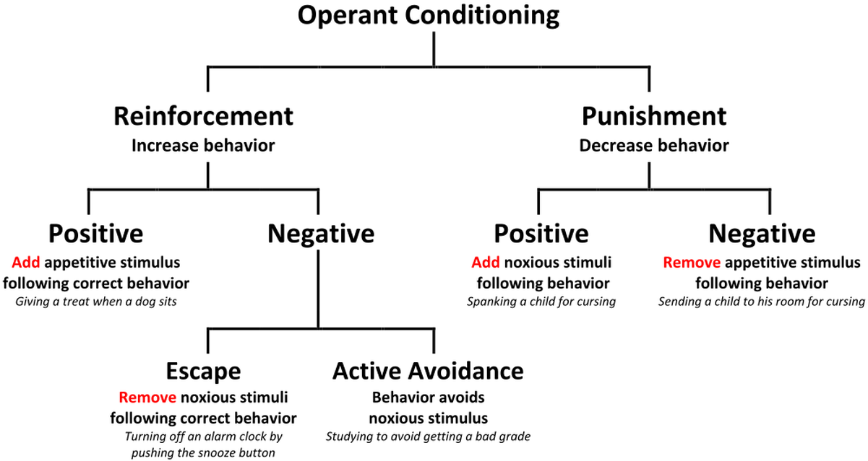

Classical Conditioning

* Systematic desensitization is a classical conditioning technique in which the intensity of an unconditioned stimulus is gradually increased until it no longer elicits the conditioned response.

Stroop Effect

* Describes the phenomenon in which it is harder for an individual to reconcile different pieces of information relating to colors than to reconcile similar pieces of information
* For the picture below, it is harder to say the *colors* in which the words are written than it is to read the *words* themselves



McDonaldization of society

* Rationalization taken to extreme level: When a society adopts the characteristics of a fast-food restaurant
* Elements include efficiency, calculability, uniformity, technological control

Norms

1. Folkway - nice to do, nothing bad if don't (hold the door open for someone else)
2. Mores - should do, slight negative if don't (being a liar/cheating)
3. Laws - should follow, there are formal consequences/ sanctions if you don't (stealing)
4. Taboo - worst of them all, severely looked down upon and may be punishable by law (incest)

Deviance

* Breaking a folkway or any other social norm is termed deviance
* Deviance can include behavior generally perceived as “bad” or morally wrong, such as stealing.
* However, it can also include actions that contradict the norms of the time, but are later thought of as morally right, such as past civil rights movements.
* **To discourage deviance, societies use many forms of social control, or formal and informal methods of encouraging adherence to norms.**
  + One example is stigma, or the extreme disapproval and rejection targeted toward those thought to have broken important norms, such as those who commit incest.
* Social pressure can backfire, as in the case of strain theory, which is the idea that when social pressure is placed on those who do not have the means to follow it and succeed, they may turn to crime and other deviant behavior.
* **Labeling theory** refers to how deviant individual behavior becomes even more deviant when a person is negatively labeled or classified as such
  + Secondary deviance is more severe than primary deviance

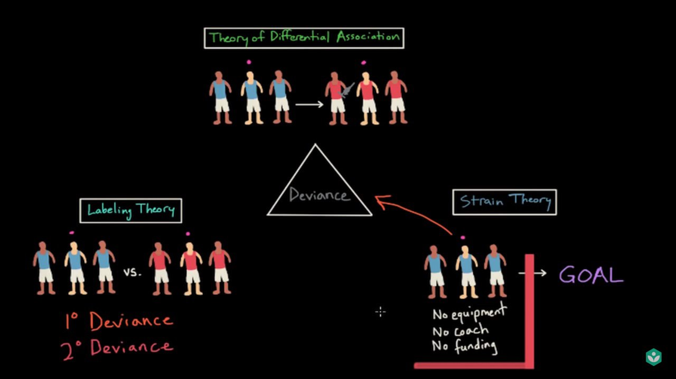

Minority Influence

* When a **new idea** arises, it is automatically a minority opinion. This idea can then be spread through the influence of the minority on others accepting this view.

Collective Behavior

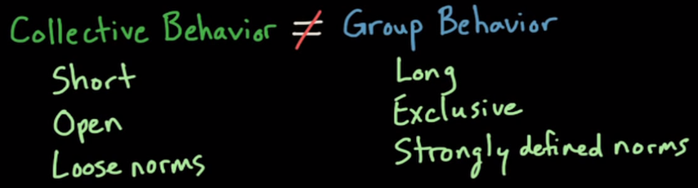

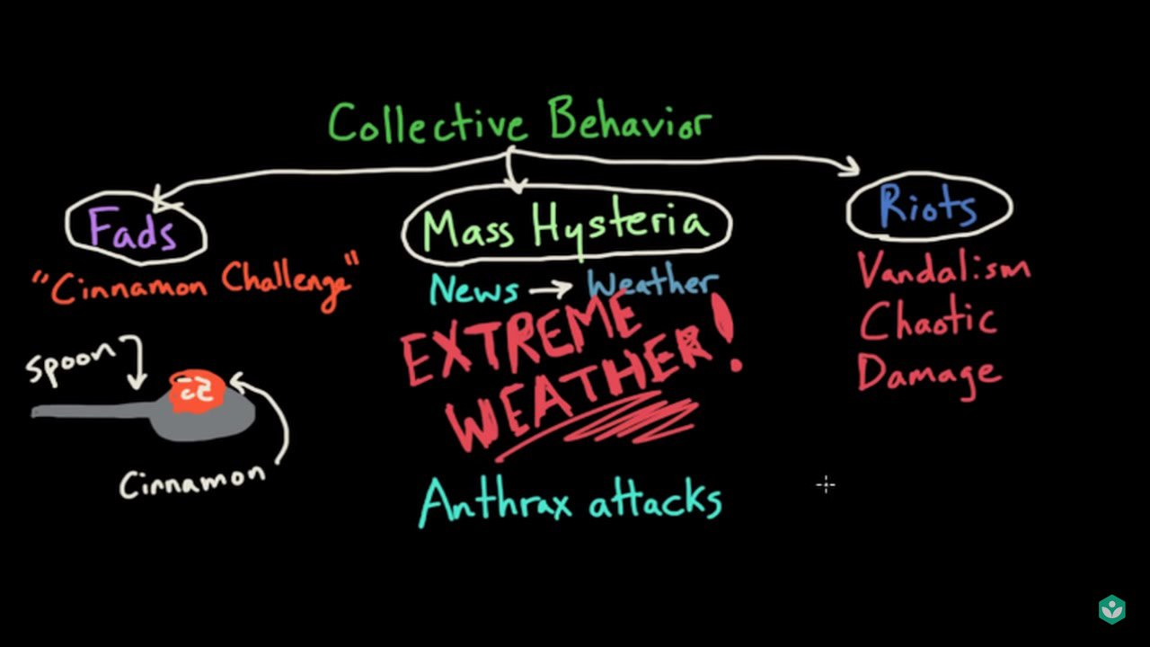

Conflict (Approach and/or Avoidant)

1. Approach-approach conflict
   1. Two options are appealing
2. Avoidant-avoidant conflict
   1. Two options are unappealing
3. Approach-avoidant conflict
   1. One option has both positive and negative aspects
4. Double approach-avoidant conflict
   1. Two options with both appealing and negative characteristics
   2. E.g. The jurors’ dilemma if they are unsure of the defendant's guilt
      1. If they rule the defendant guilty, they would either be punishing a criminal (approach) or punishing an innocent (avoidant).
      2. If they rule the defendant innocent, they would either be letting a criminal walk away unpunished (avoidant) or freeing an innocent (approach).

Motivation vs Drive

* Motivation can be **internal** (based on internal drive or perception) or **external** (based on external circumstances)
* Drive can be **primary** (those that motivate us to sustain necessary biological processes e.g. hunger) or **secondary** (those that motivate us to fulfil nonbiological, emotional, or “learned” desires e.g. getting in med school)
  + Motivation arises from the desire to **eliminate drives**, which may cause uncomfortable internal states
  + Eliminate options that contain ‘drive’ if the question stem does not suggest an uncomfortable internal state or tension

Group dynamics

* Larger groups (e.g. triad) are generally considered more stable but less intimate, whereas smaller groups (e.g. dyad) are usually considered less stable but more intimate.
  + However, this is not always true. From Princeton review, "In a triad there are more relationships which can result in increased or decreased tension. Decreased tension results from the third person acting as a mediator of tension between two (think couples counseling) increased tension can result from two of the members teaming up on the third." So their explanation that "the triad ... is considered relatively more stable because of additional social ties"
* Dyads, two-person groups such as the physician–patient group, are unstable because either party can break the single social tie

Social Loafing

* Classic example of why you should not impose your own opinions but make use of whatever you have learnt to answer the question

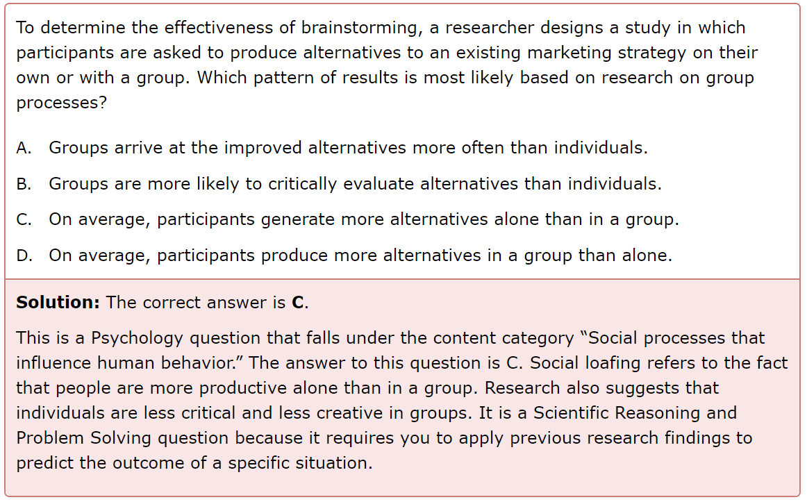

Interaction process analysis

* Revised to the system for multiple level observation of groups (SYMLOG):
  + Dominance vs submission
  + Friendliness vs unfriendliness
  + Instrumentally controlled vs emotionally expressive

Interpersonal Attraction

* Both males and females tend to be attracted to high levels of sexual dimorphism e.g. males having V shape torso (“physical attraction bias”)
* We prefer the average prototypical face rather than unique face
* If we are shown a picture of a female on a narrow bridge, we might mistakenly like her more due to increased heart rate / sympathetic arousal that is actually caused by the danger element
* We like people who are like us: We are more attracted to people who display some similar features as our own, e.g. deem them to be more trustworthy (“similarity bias”)

Proximity and Mere Exposure Effect

* Proximity: meet and mate with someone who live in the same area as you
* Mere Exposure Effect: repeated exposure to novel people or objects or stimuli increases our liking for them, even though there are cases that violate this e.g. hating the same music that keeps playing again and again → advertisers make use of this (“familiarity bias”)
  + First study: Girls (all of them with equal attractiveness, did not interact with each other) who attended lectures more are rated to be more attractive
  + Second study: Participants with anterograde amnesia (cannot form new memories) came to the lab for the first time, were shown some pictures of people, and then came back another day, and rated that these pictures higher among all the pictures, despite them not being able to remember the faces

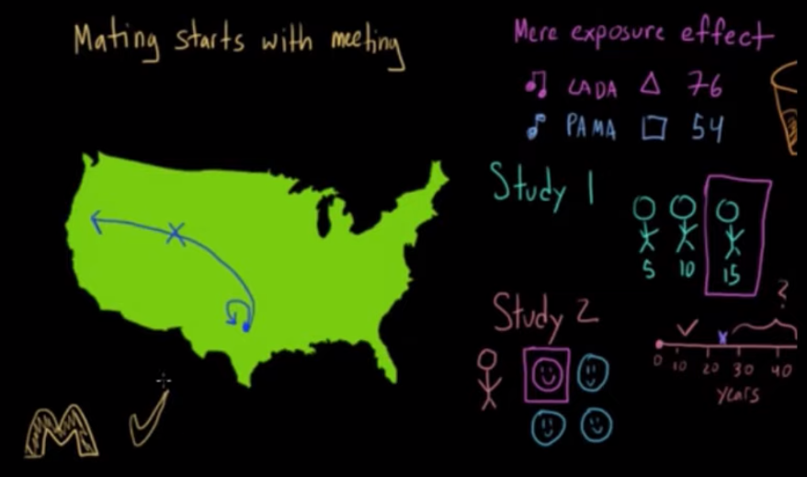

Theories of language and cognition

* Whorfian Hypothesis (strong linguistic determinism): language determines thought completely.
  + For example, a tribe has an entirely different perception of time because their language has different words for time.
* Weak linguistic determinism: language influences thought, but does not determine it completely.
  + For instance, we all read left to right and this is why it's easier for us to draw left to write, or if we imagine something in our head, it's left to right.
  + For instance, picture a soccer player in your head running down the field and scoring a goal. There was a very high chance you imagined this player running left to right.
* Whorf-Sapir: We have certain thoughts we have in one language that cannot be understood by those who exist in another language.
  + This is kind of an extension of the Whorfian hypothesis and to use that last example, it would be like saying that that same tribe could never understand time the same way we do because they cannot speak our language.
* Linguistic Universalism: Thought determines language completely.
  + Basically this is the opposite of the Whorfian hypothesis.
  + This is like saying that the reason that the tribe has different words for time is because they can only perceive time in that way.

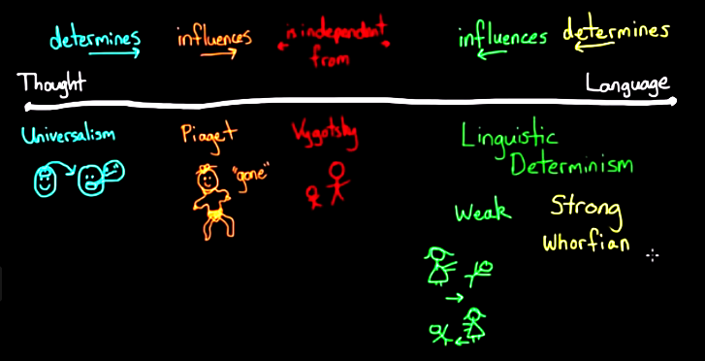

Caste vs Class vs Meritocracy

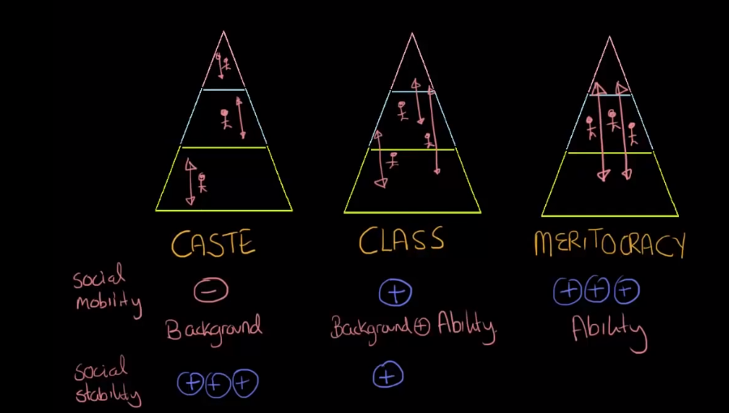

Poverty

1. Absolute Poverty
   1. Focuses on survival, the bare minimum
2. Relative Poverty
   1. Focuses on **social disadvantage** by income or wealth as **compared** to the social advantages linked to income or wealth in a society
   2. Being excluded from society even though your income could be way above the absolute poverty line
3. Marginal Poverty
   1. A person cannot find a job
4. Structural Poverty
   1. Refers to the idea that people are poor because of how society is structured rather than individual reasons (systems fault vs. individuals fault)

Class Consciousness vs False Consciousness

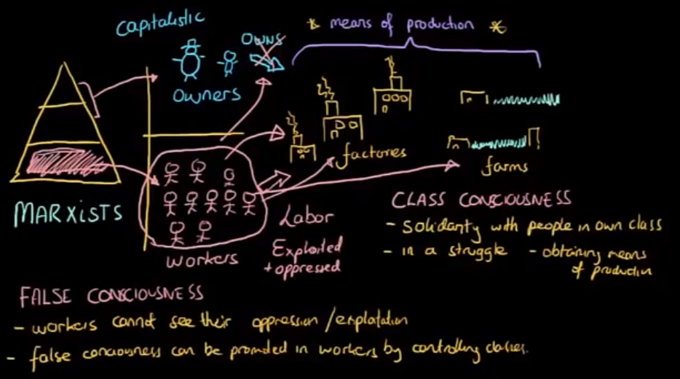

Experimental Design and Variables

* Depending on what researchers are studying, they can either employ a cross-sectional design or an experimental design.
  + Cross-sectional studies investigate a population at a single point in time, looking for predictive relationships among variables.
    - A limitation of cross-sectional designs is that they can show correlations, but not causation, because looking at changes over time is necessary to assess whether a cause-and-effect relationship is present.
  + An experimental design involves manipulating a certain variable—known as an independent variable—to see what effects it has.
    - The measured effects are known as dependent variables. Additional types of study design exist, especially in the social sciences; of note, qualitative research focuses on analyzing experiences rather than objective metrics.
* In any experiment, it is important to include controls.
  + Negative controls are treatments that are known to have no effect
  + Positive controls are treatments that are known to have a certain effect and can therefore be used to assess whether the experimental methodology was sound.
* In clinical contexts, experimental studies often use a double-blind design in which neither the subjects nor the researchers know who is receiving the treatment and who is receiving the control.
* In experimental design, there are several types of variables:
  + Confounding variables, which are external variables affecting both the independent and dependent variable.
    - For instance, if a study analyzes the effects of stereotype bias on math performance by race, but fails to account for socioeconomic status (SES), its results may be suspect, because SES may predict math performance and be correlated with race.
  + Moderating variables attenuate or strengthen a given relationship
  + Mediating variables provide an important logical link between an independent variable and a dependent variable, or outcome.
* Types of validity:
  + Internal validity
    - Means that the study has internally been well constructed, using things like large random samples, safeguards against confounding variables, reasonable and reliable processes and instruments, etc
    - Any threats to the internal validity of the study created by the repeated measures approach can usually be addressed through counterbalancing
    - If a study is internally valid, we can then assess whether it has external validity (next point)
  + External validity
    - Refers to the generalizability of the research to settings beyond this study
    - An experiment must tightly control any situational variables in the execution of the study
    - E.g. if a study only shows that X is related to Y for this experimental group, then it’s not very valuable for drawing conclusions about the larger population
  + Criterion validity
    - Refers to whether a variable is able to predict a certain outcome
  + Construct validity
    - Refers to how well a given assessment (a survey, a test, etc) actually measures what it claims to measure— whether it has been properly constructed to measure the relevant thing
    - E.g. A study purports to examine how social class influences perception of race. However, if the categories of “Black” and “White” are viewed by participants as being categories of social class rather than race, then they are not reflecting what the researchers intend to measure (participants’ views of race). This is a problem with construct validity, or the manner in which the terms of the study are defined.

Valid vs Reliable vs Generalizable vs Standardized

1. Validity -- does the test/research method actually measure what we want to measure?
   1. E.g. The MCAT would be considered a valid test if it predicts medical school preparedness/success.
   2. The best way to test validity is to have two tests that correlate to actually correlate, meaning if a high score on both tests links to the hypothesis being tested. To show a lack of validity, these tests need to point in the opposite direction, meaning one test proves the hypothesis with a high score but somehow the second test disproves the hypothesis, creating a conflict in the study
2. Reliability -- if a single individual will tend to score similarly every time he/she takes the test, then it's reliable.
   1. If someone takes 3 MCAT exams, *without any extra preparation in between* and he/she scores a similar score every time, then the test is reliable. This is also true for research methods (for example, does a single rat complete a maze task in roughly the same amount of time every time).
   2. Reliability can be limited by the "practice effect", which is the tendency of subjects to do better on a task the more often they do it because of the practice.
3. Generalizable -- how good can the results of a particular research be applied to a large group of people (same definition as external validity)
   1. For example, a good clinical trial is one that can be generalized to the whole population that has that disease. If we have a clinical trial for a new drug used to treat macular degeneration, then the results of that study should be able to be applied to everyone else that has macular degeneration.
   2. This can also apply to tests--is the result of an MCAT exam indicative of any single person's future success in medical school? If so, then you'd say that the MCAT is a generalizable exam that can be used to assess anyone's medical school success.
4. Standardized -- is every single test/trial administered the same exact way to all people who take it?

Correlation vs Causation

* Causation
  + You need a **controlled experiment** to determine causation (e.g. double blind, placebo controlled study) → you need **dependent** and **independent** variables
  + E.g. If I take away sleep from you then you are more likely to eat
* Correlation
  + Trying to see how some variables influence something else, usually by **observing**
  + **No such thing as dependent and independent variables**
  + Too many confounding variables so you cannot simply imply that the relationship is causation

Types of bias and errors

1. Reconstructive bias
   1. Related to memory
   2. Most research on memories suggests that our memories of the past are not as accurate as we think, especially when we are remembering times of high stress
2. Attrition bias
   1. Occurs when participants drop out of a long-term experiment or study
3. Selection bias
   1. Related to how people are chosen to participate; non-random sample, so the study population is not representative of the target population
   2. Mainly addresses internal validity for differences or similarities found in the sample at hand
4. Sampling bias
   1. A type of selection bias where some members of the target population are less likely to be selected than others
   2. Undermines the external validity of a test i.e. the ability for the results to be generalized to the rest of the population
5. Time-interval bias
   1. Early termination of a trial when its conclusions support a hypothesis
6. Exposure bias
   1. A type of bias where cause and effect are misinterpreted when a new factor, like a treatment, is introduced
7. Self-serving bias
   1. The common human tendency to attribute one's successes to personal characteristics, and one's failures to factors beyond one's control
8. Hindsight bias
   1. The, Ha! I knew it all along! Effect
   2. Refers to the tendency for a person to overestimate how well he or she could have successfully predicted a known outcome (i.e., a “forecast,” given before the outcome was known).
9. Response bias
   1. The tendency of respondents to provide untruthful answers due to social-acceptability; Social desirability bias is a type of response bias
   2. E.g. responding to interview questions in a socially acceptable manner
10. Fundamental attribution error
    1. People are more likely to make dispositional (internal) attributions, especially in a negative context
11. Attribute substitution
    1. When we use a heuristic to or simpler solution in place of a complex judgement - explains some optical illusions
12. Misinformation effect
    1. An incorrect recollection of an event due to information provided after the event
    2. A form of retroactive interference
13. Pygmalion Effect
    1. A form of self-fulfilling prophecy where higher expectations lead to improved performance
14. Observer-expectancy effect
    1. Where a researcher's expectations cause them to unintentionally bias the outcome of a study
15. Hawthorne Effect
    1. When participants modify their behavior when they know they are being observed
16. Error of central tendency
    1. An unwillingness of raters to provide very high or low ratings
17. Bias blind spot
    1. Seeing the impact of bias on others' judgement while failing to see one's own bias
18. Base rate fallacy
    1. Refers to the error people make when they ignore the base rates (i.e., prior probabilities) when evaluating the probabilities (or frequencies) of events

Normal Distribution

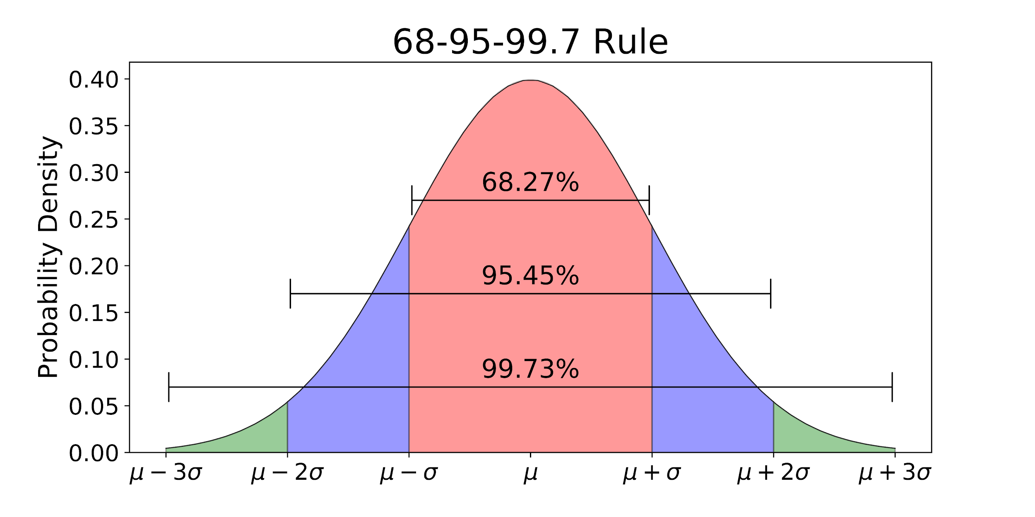

Skewness

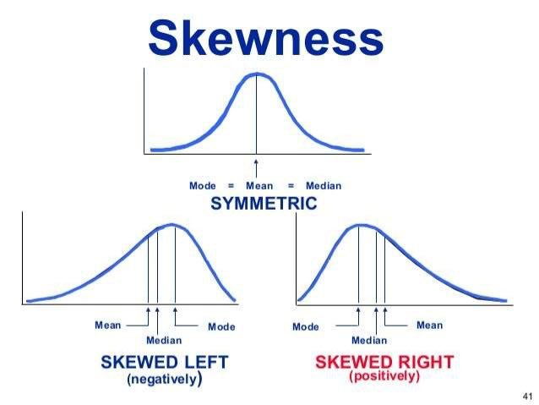

Type I vs Type II errors

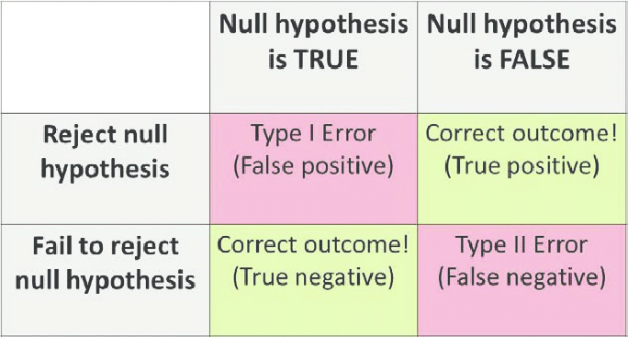

Between-population vs within-population

* Between-population: how the dependent variable (response) of different populations (e.g. children vs adult) varies for the same independent variable (e.g. exercise condition)
* Within-population: how the dependent variable (response) of the same population (e.g. adult) varies given different independent variables (e.g. exercise condition vs sedentary condition)

Error bars

* If they do not overlap, it implies statistical significance (even though the asterisk is not given in the question)

